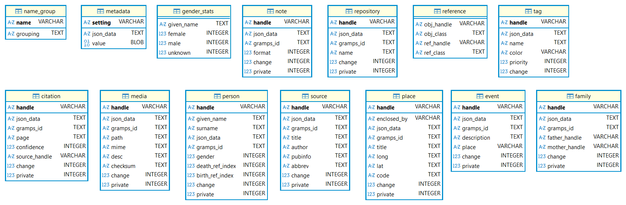
This is an Entity-Relationship Diagram (ERD) for the database setup with the Gramps Software. Every table, except for reference, has a primary key. The primary keys are not linked to each other. The master table is the reference table. This table is used to link data amongst the other tables.
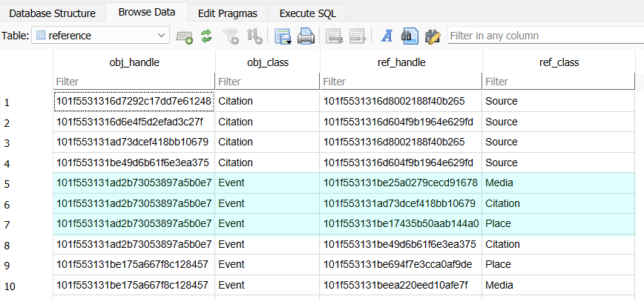
In the pictured example, the highlighted objects are an event. It is linked to an object in media table, something on the citation table, and an object on the place table. The handles are the primary keys from the respective tables.

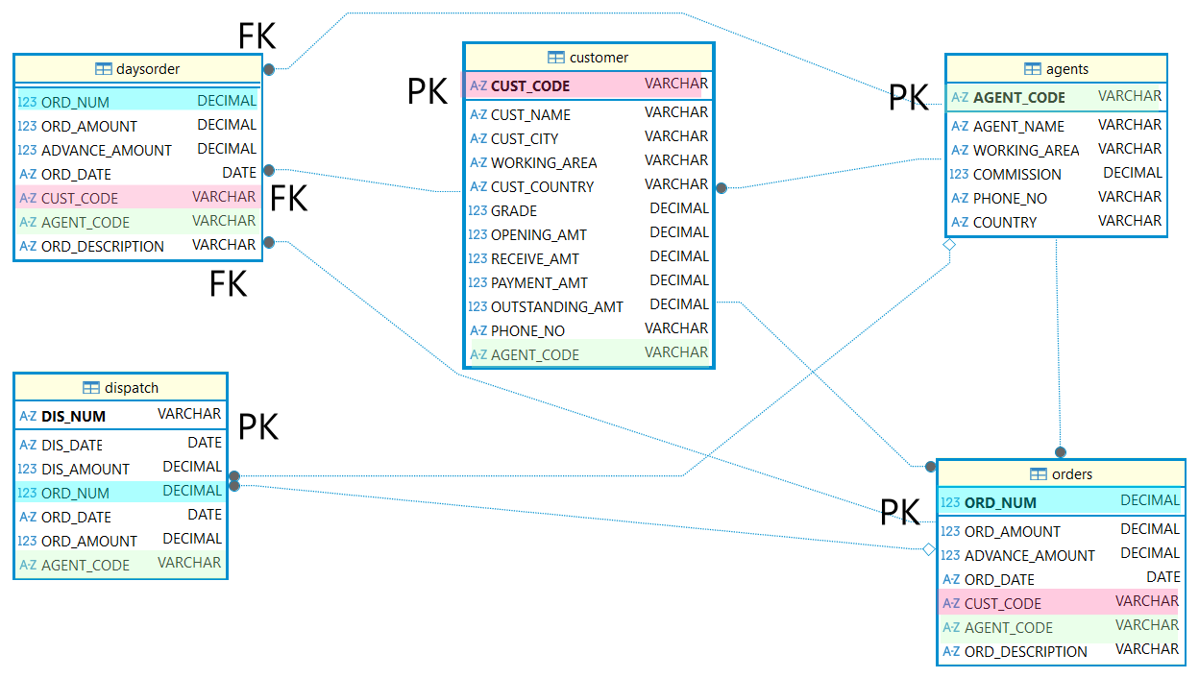
This sample ERD shows a DB using primary and foreign keys. The diagram shows no primary keys on the daysorder table, but all three foreign keys are primary keys on their respective tables. While AGENT_CODE is a primary key on the agents table, it is not a primary key on the dispatch, customers, daysorder, and orders tables. The primary keys are shown on their respective tables by being in bold, at the top, and separated by the rest of the keys. This diagram was developed in the IDEF1X format.

